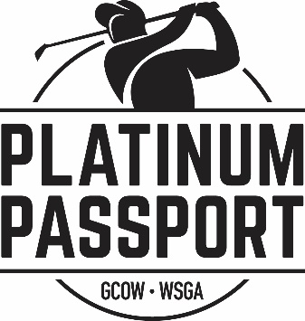
2023 Platinum Passport
Frequently Asked Questions (FAQ)

Q. The Platinum Passport Sounds too Good to Be True – What is the Catch?
A. No catch!! The Passport is the best deal in golf and what you see listed is exactly the deal you will get!

Q. You get FREE greens fees – how is that true?
A. It is TRUE! We have received great working relationships with many of the courses in the state through the GCOW & WSGA and these courses are offering the greens fees for FREE for this program

Q. What does FREE rounds exactly mean?
A. It means that the golf courses are offering FREE GREENS FEES – either a FREE ROUND (1 person) or a FREE TWOSOME (2 players). The Platinum Passport purchaser can in most cases bring a guest and that there are FREE GREENS FEES for both players.

Q. FREE Golf? Do we have to pay for carts?
A. In most cases YES. Since this golf is 100% DONATED to us, the only revenue the course receives is thru cart fees, their pro shop, food, etc. If you have TWO (2) golfers, both will have to pay the cart fee.

Q. Are their restrictions?
A. YES. Most courses have different restrictions, while some may have none. Some have day of the week, time of the day, etc. restrictions. Again, since they DONATE this too us, some of their blackout times are when they are busy with regular tee times.

Q. Can I golf a course more than one time with the Platinum Passport?
A. No. The Platinum Passport is a booklet with a coil bound “Tear-out” pages for each of the courses. So once that “Page” is used, it is done. However, if you and a friend each buy a passport, you could use your Passport at a course once and then go to the same course with your guests’ Passport another day.

Q. If I cannot get to a course, can I let my friend take the Passport book to use with someone.
A. YES. Although we don’t promote that you can share the book, you can. If you cannot get to a course up north etc., you may give someone the book to use. HOWEVER – DO NOT tear out the course page, give them the entire Passport book. If a page is torn out of the book before turned in at the Pro Shop, it is NOT VALID, and courses can refuse to accept it. So, keep the book and pages intact.

Q. Can I buy more than one Platinum Passport and is there a discount if I do?
A. YES. For every Passport you buy after one, we will take $40 off the next books up to FOUR. So, 2 books (SAVE $40), 3 books (SAVE $80), 4 books (SAVE $120).

Q. Can I take more than one person with the Passport?
A. Of course, you are encouraged to bring a foursome. However, the Passport is only good for yourself and one guest for FREE GREENS FEES. The other members of their group would just have to pay the courses regular greens fees and car fee. That is why many groups buy TWO (2) Passports, so they get FOUR (4) FREE greens fees!

